ST. JUDE
BULLDOG
BASH
Saturday, March 25, 2017
7:30 PM – 12:00 PM
St. Jude New Gym

$25 Pre-Sale, $35 at the door
Per person (checks payable to SJAA)

Tickets can be purchased through school. Please mark Bulldog Bash, name, and homeroom number on an envelope

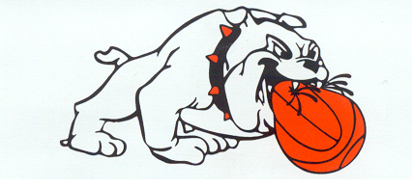
Music by
TRESSLER COMET
Includes snacks, hors d’oeuvres, and drinks
Raffle opportunities available
Proceeds benefit St. Jude Athletic Association and PTO

